Name:M.Ravi Krishna

Id:2000031169

CLOUD DEVOPS PROJECT

Create IAM roles in aws account:

Ec2fullaccess

amazonRoute53fullaccess

Amazons3fullaccess

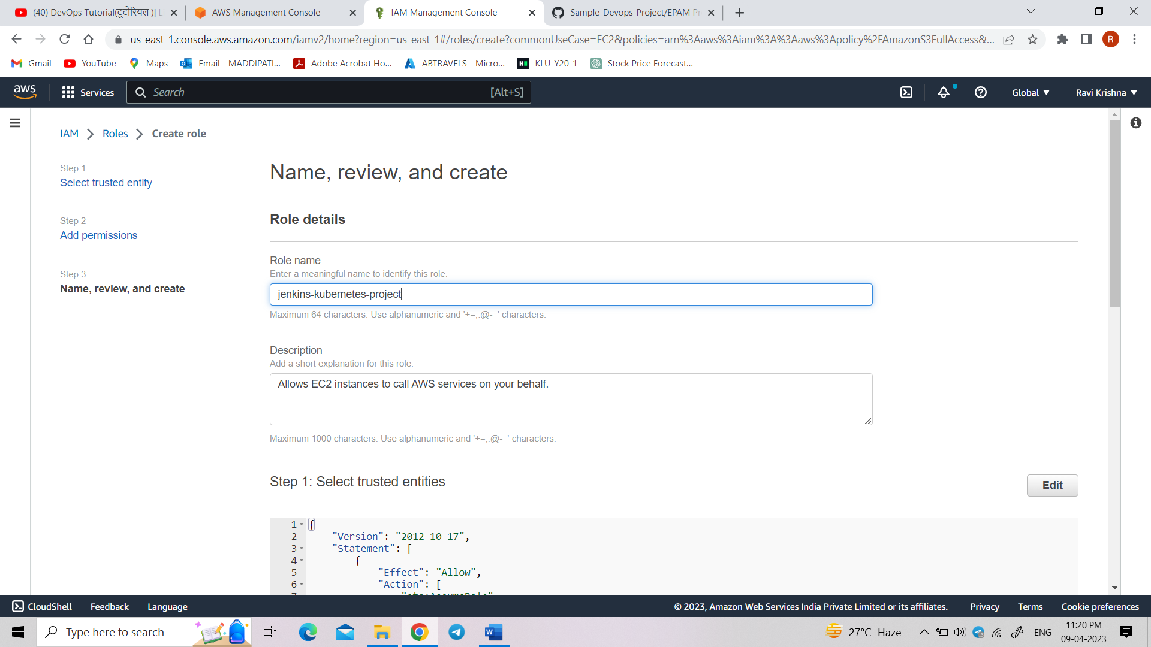

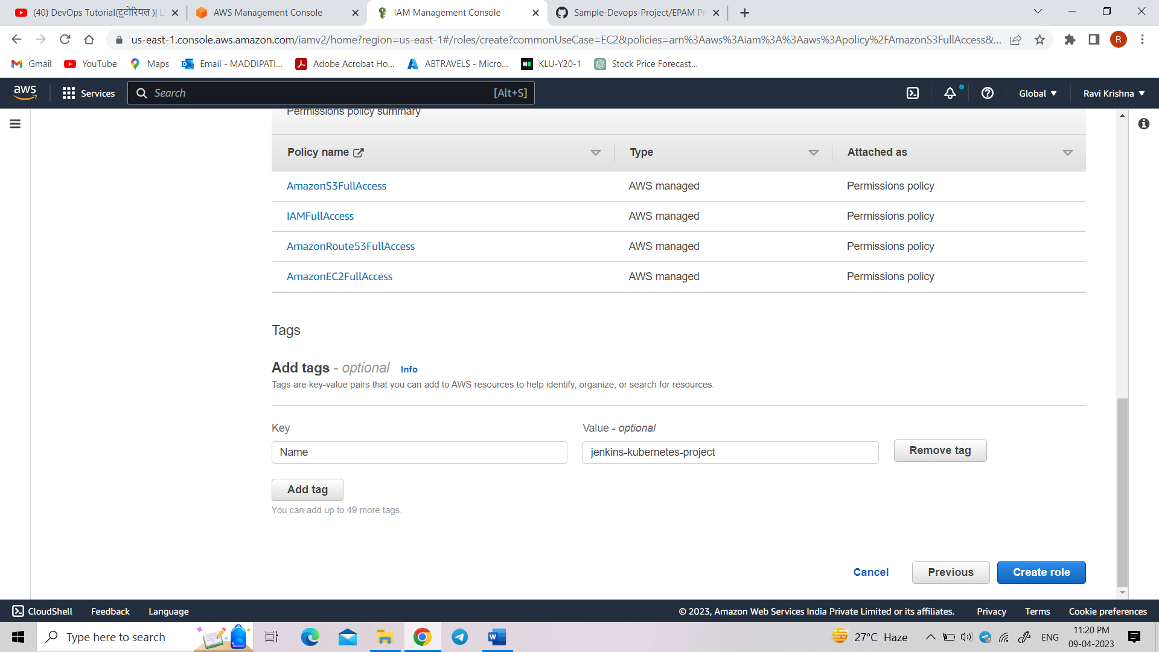

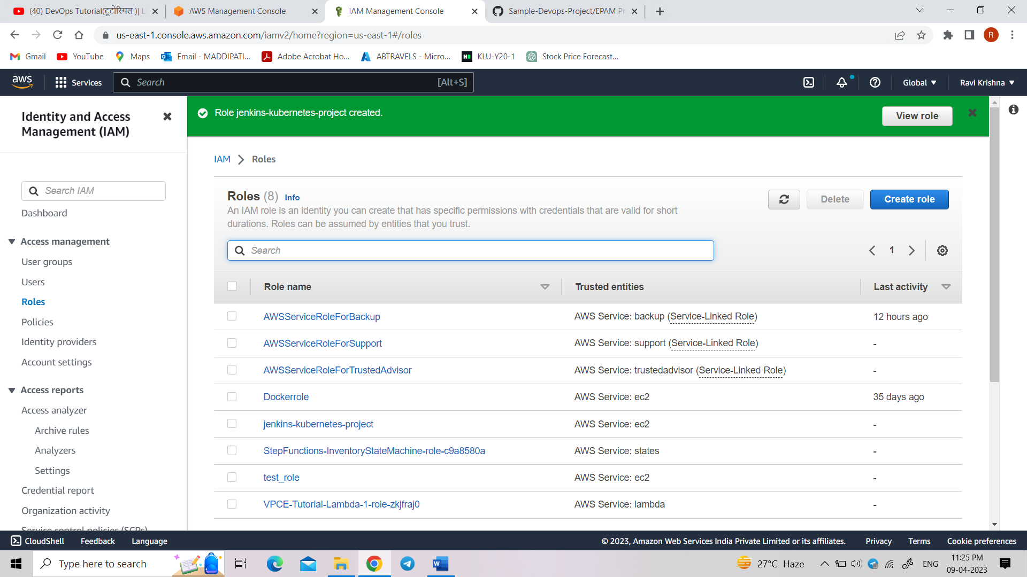

Now create an ec2 instance:

Select the newly created IAM role “Jenkins-Kubernetes-project”

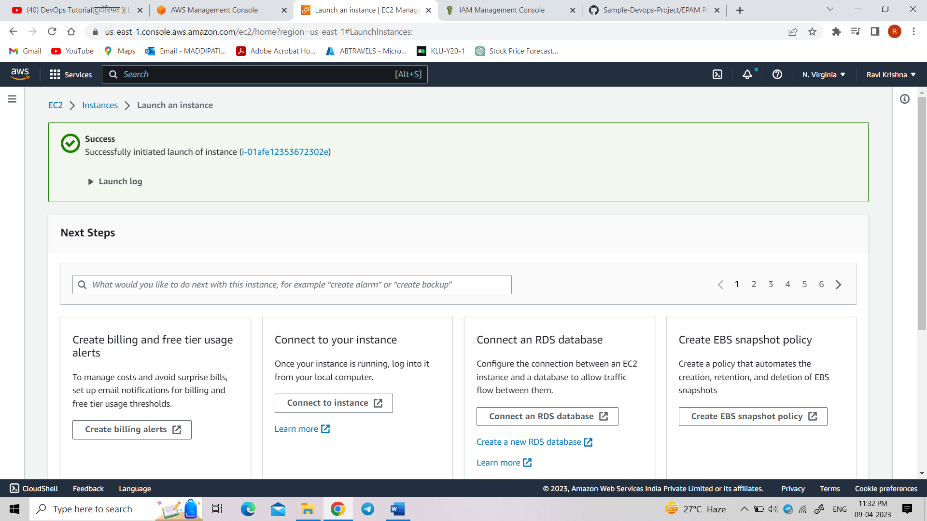

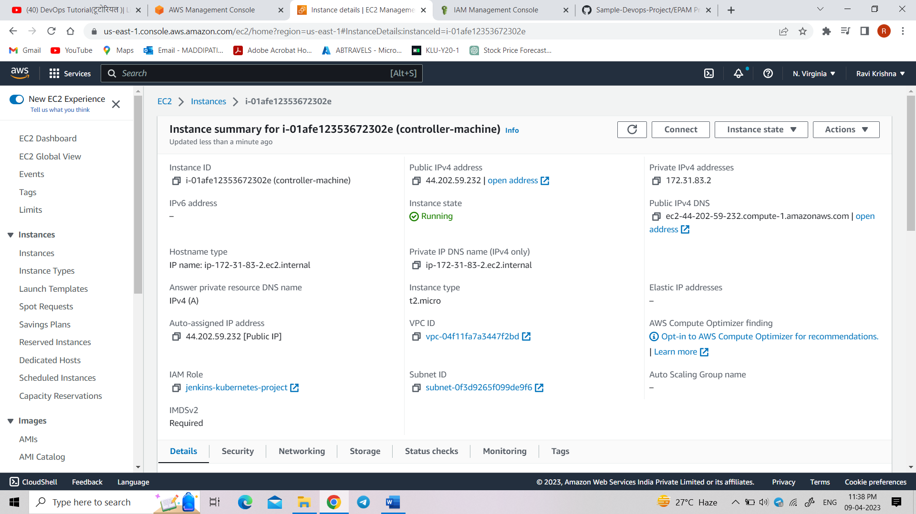

Connect to ec2 instance:

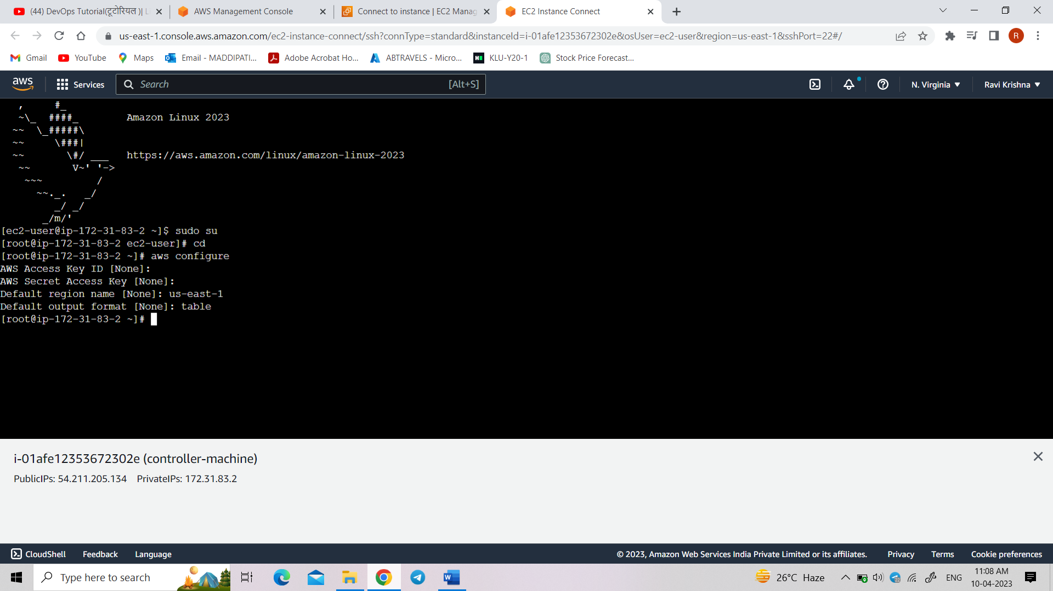

Installing kops using command

“curl -LO https://github.com/kubernetes/kops/releases/download/**$(**curl -s https://api.github.com/repos/kubernetes/kops/releases/latest | grep tag_name | cut -d '"' -f 4**)**/kops-linux-amd64”

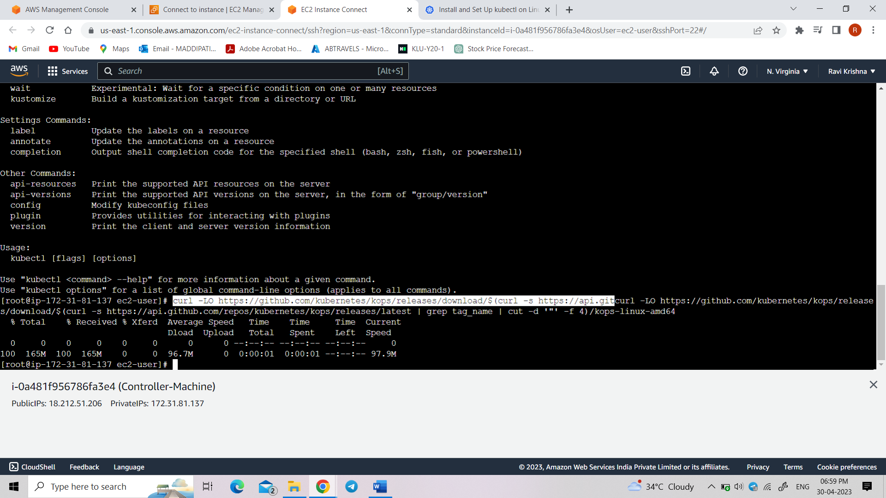

Now make kops binary executable

“chmod +x kops-linux-amd64”

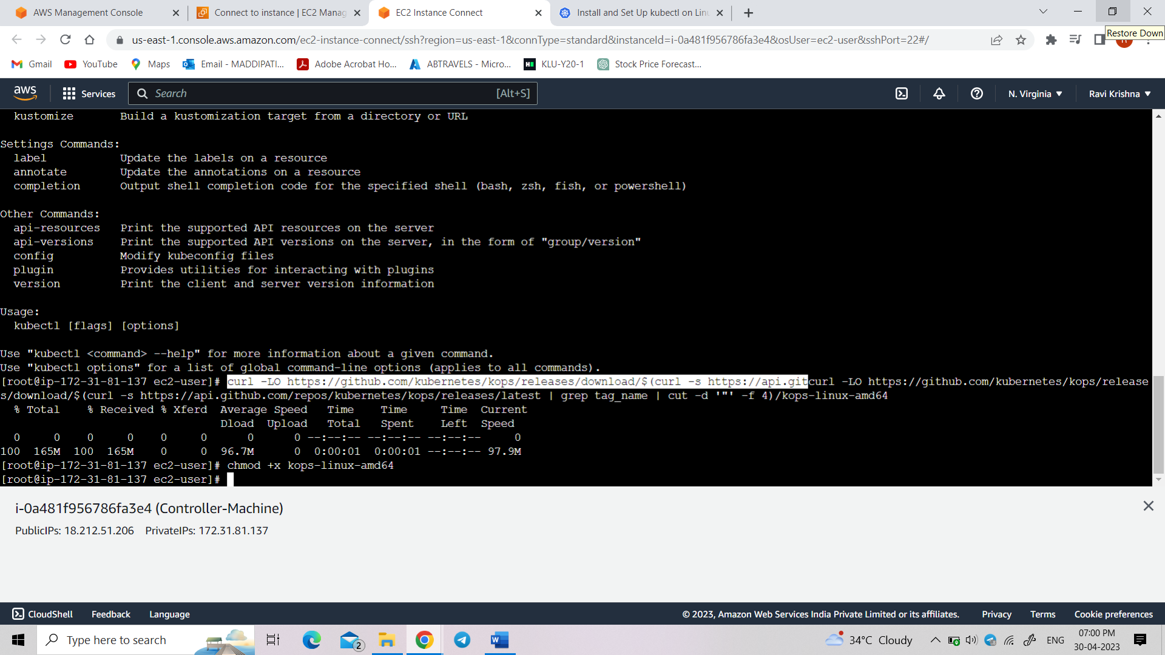

Now make the kops binary into your path

“mv kops-linux-amd64 /usr/local/bin/kops”

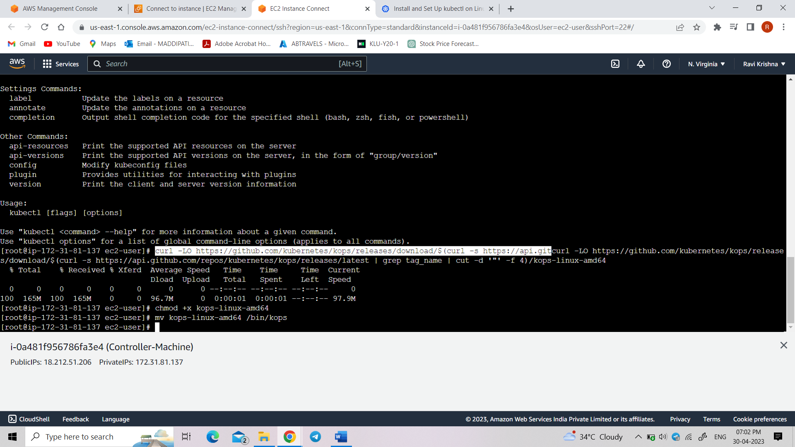

Amazon route 53

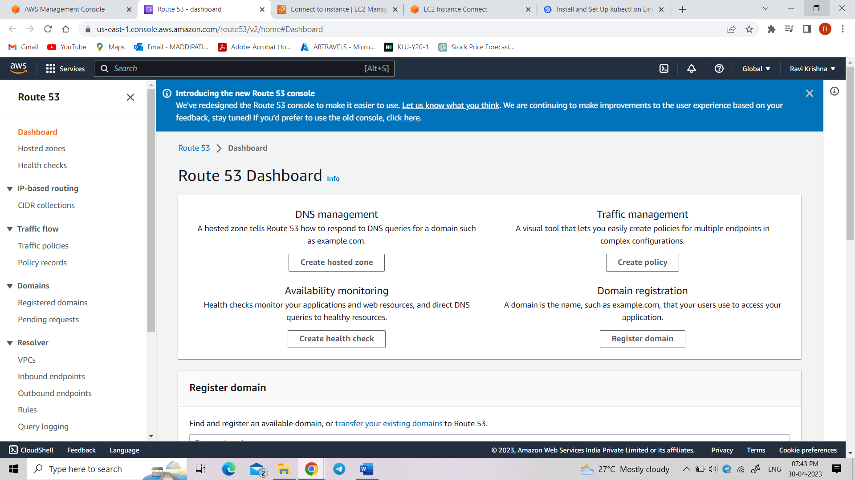

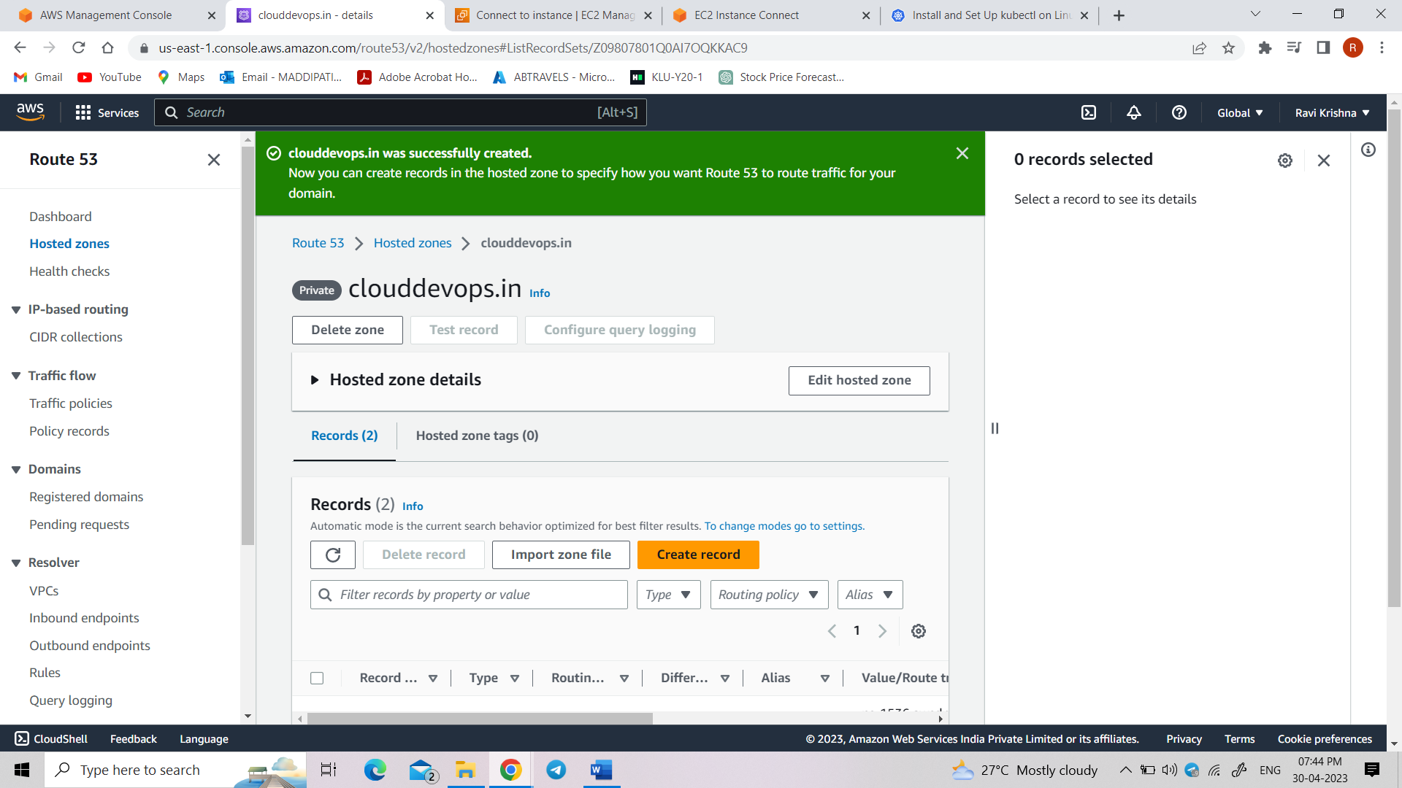

Now create s3 bucket using

“Create the S3 bucket using aws s3 mb s3://clusters.dev.clouddevops.in”

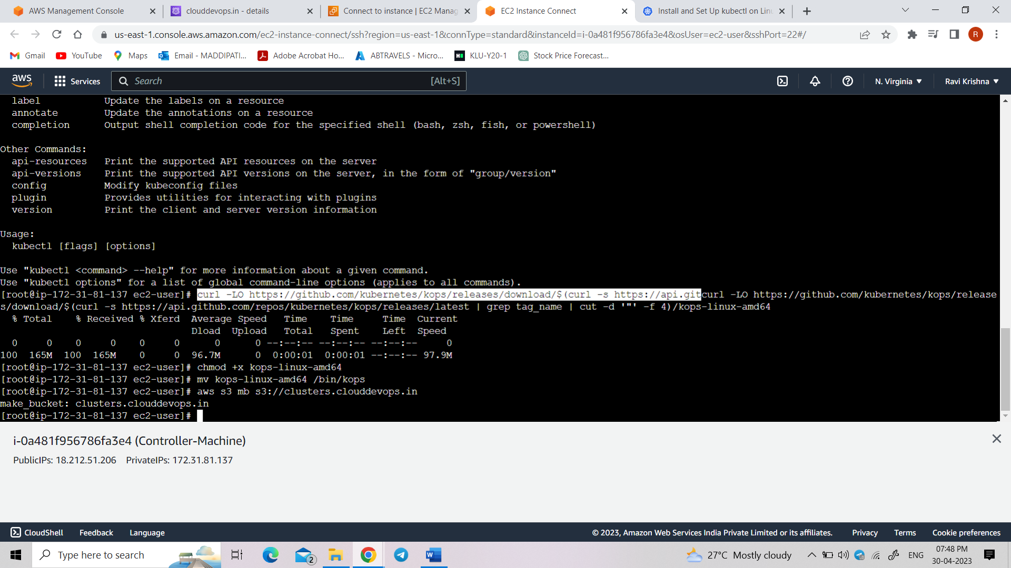

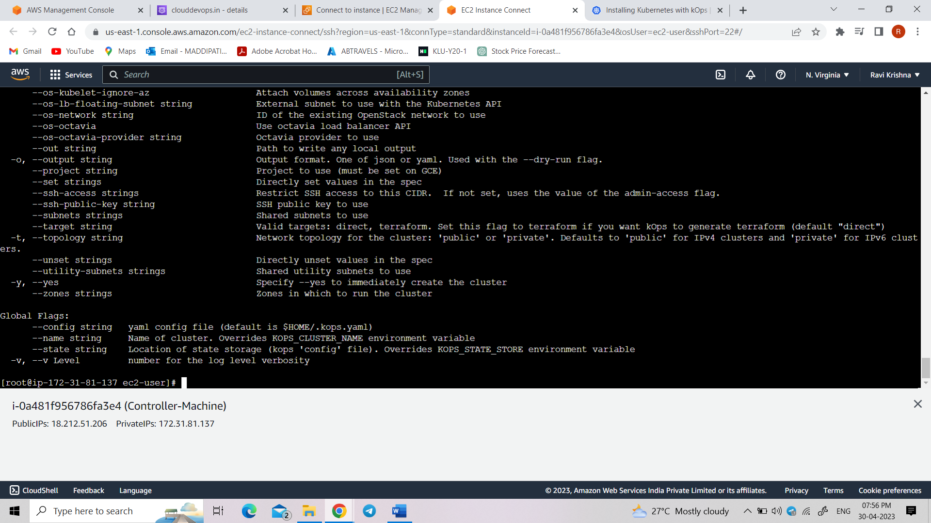

“kops create cluster --cloud=aws --zones=us-east-1 --name=clusters.clouddevops.in --dns-zone=clouddevops.in --dns private”

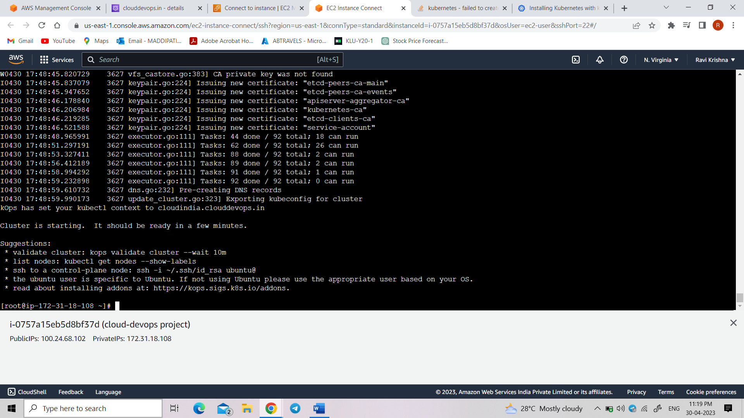

Now create 2 instances

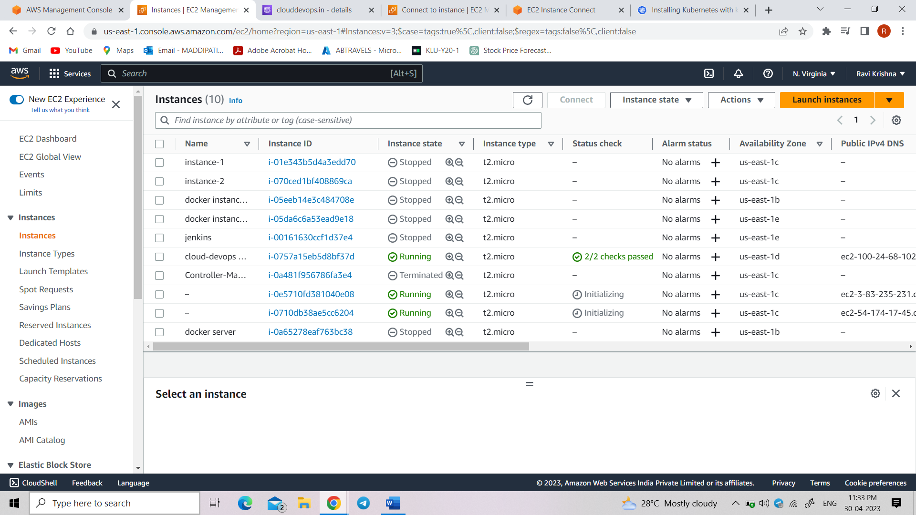

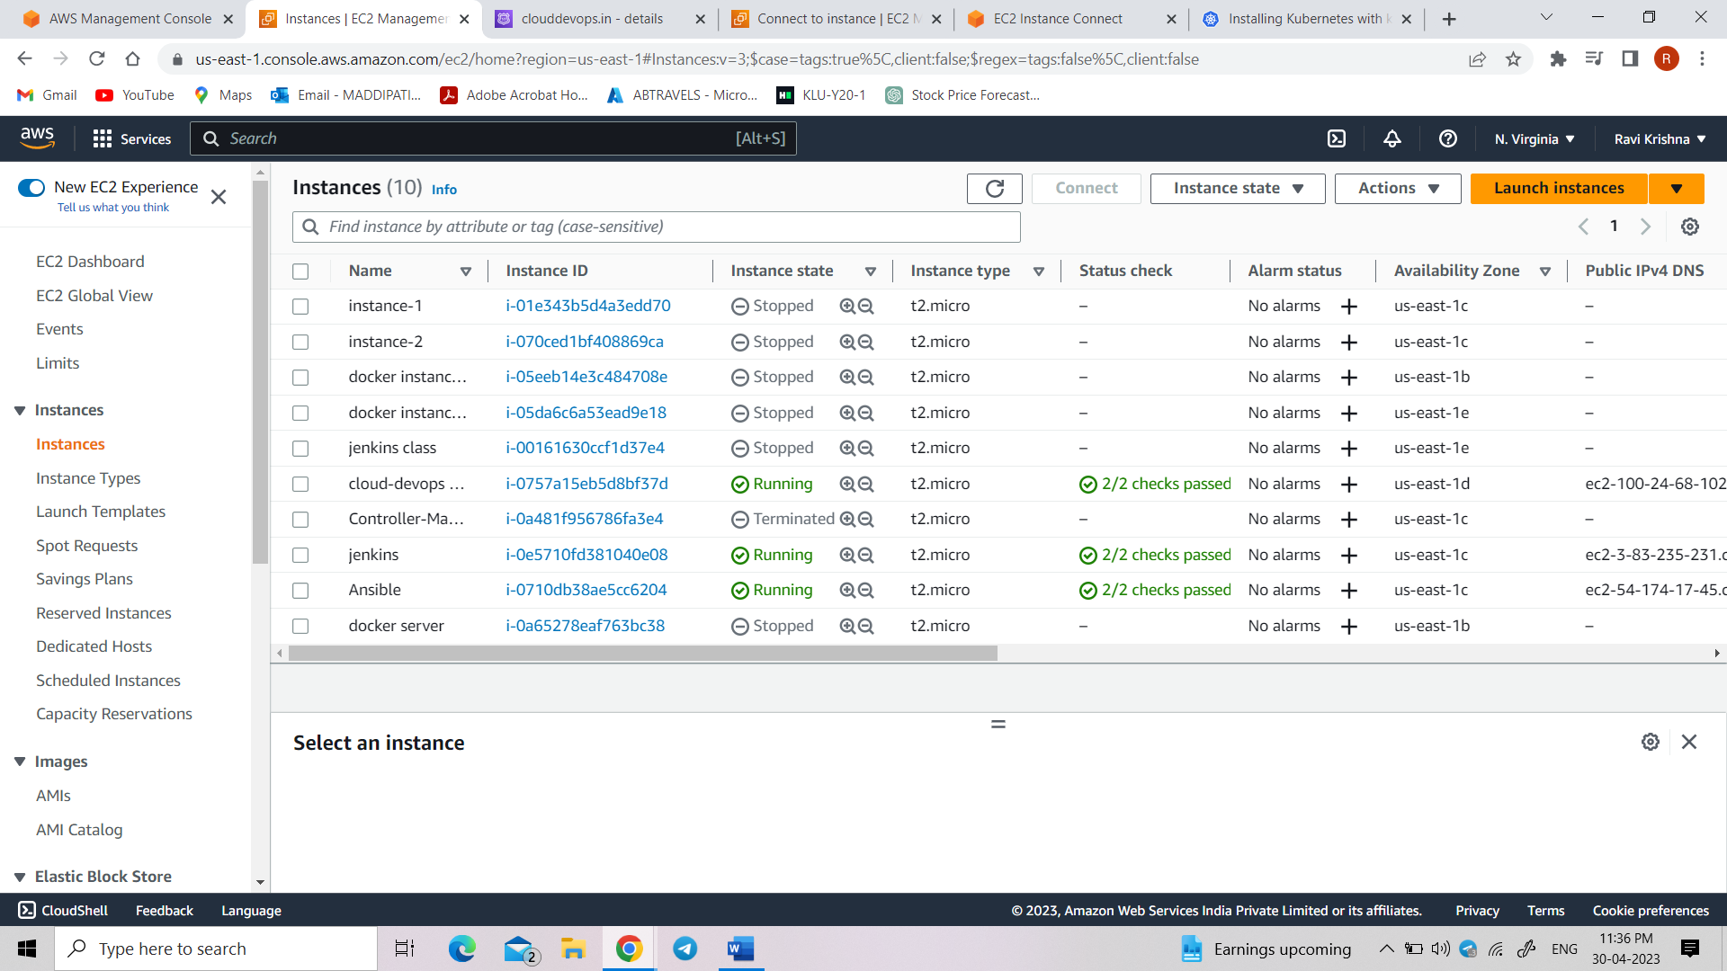

Connect to the Jenkins instance

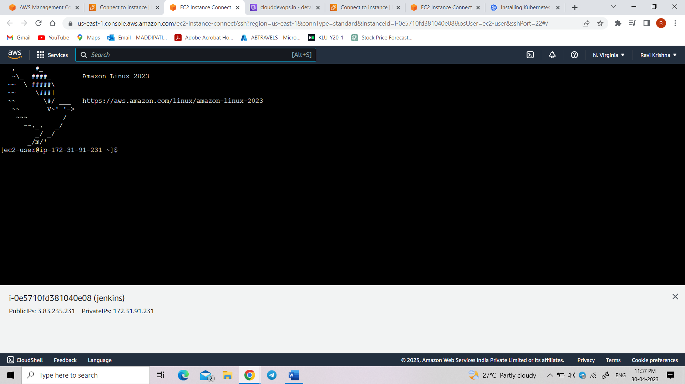

Install java in Jenkins using “yum install java”

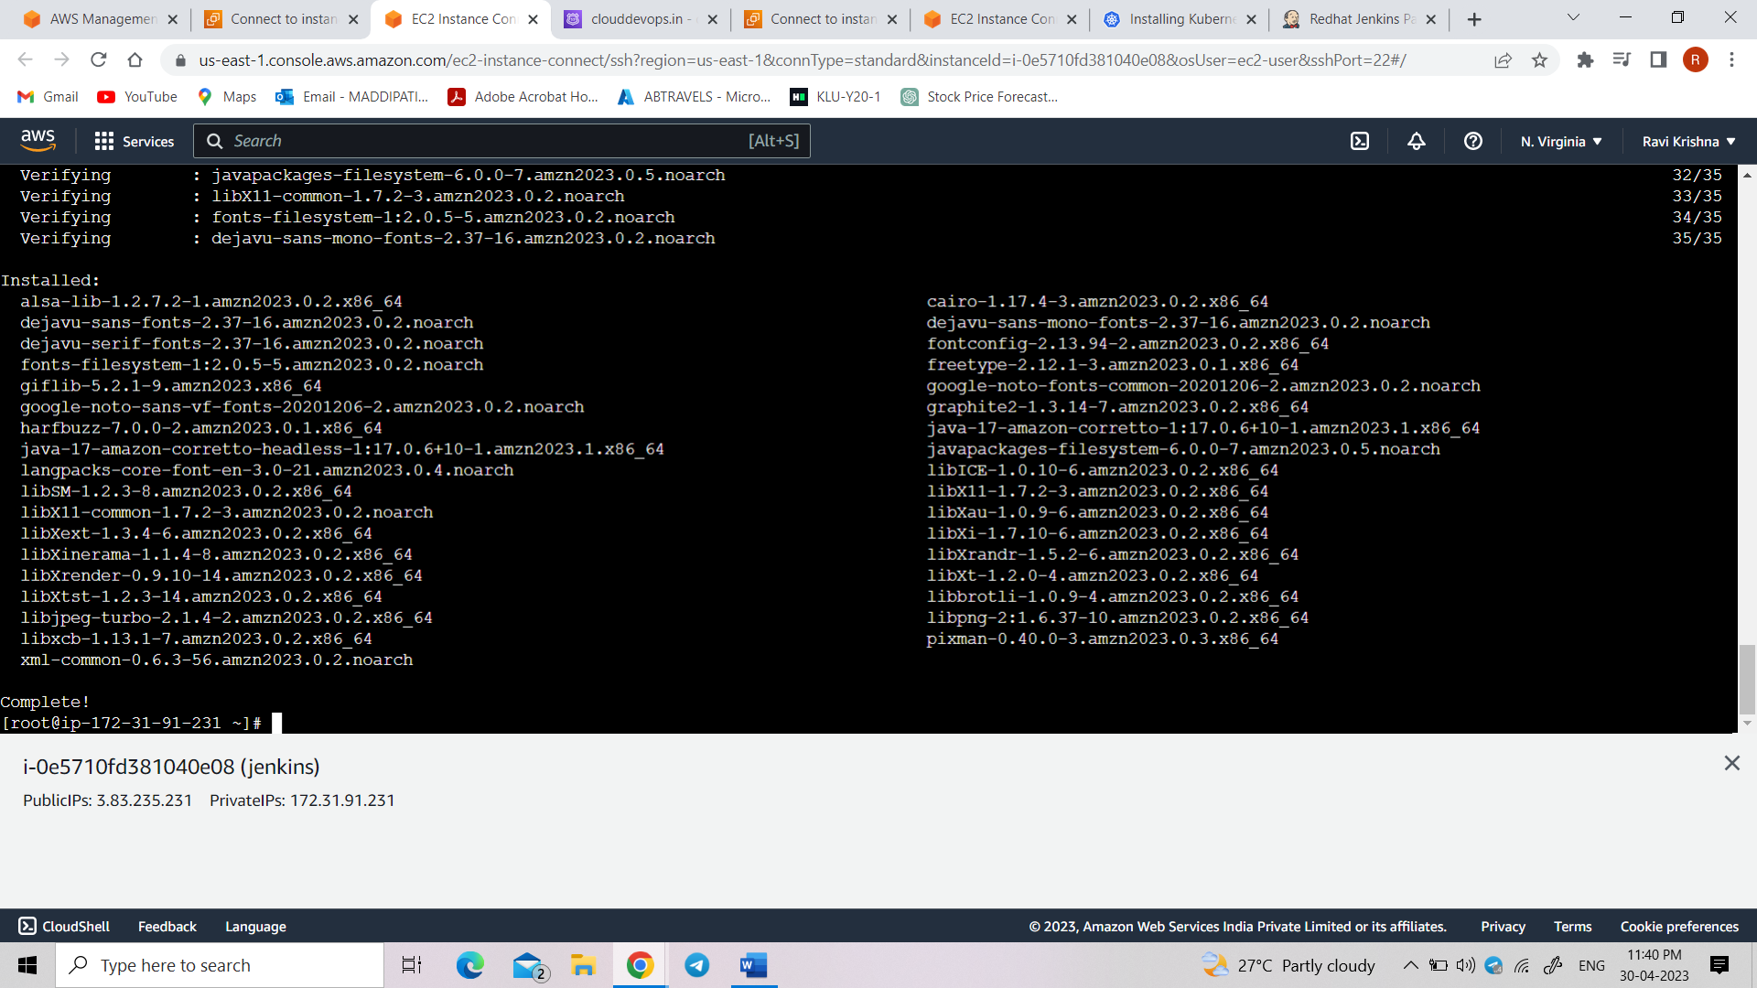

Install Jenkins using “yum install Jenkins”

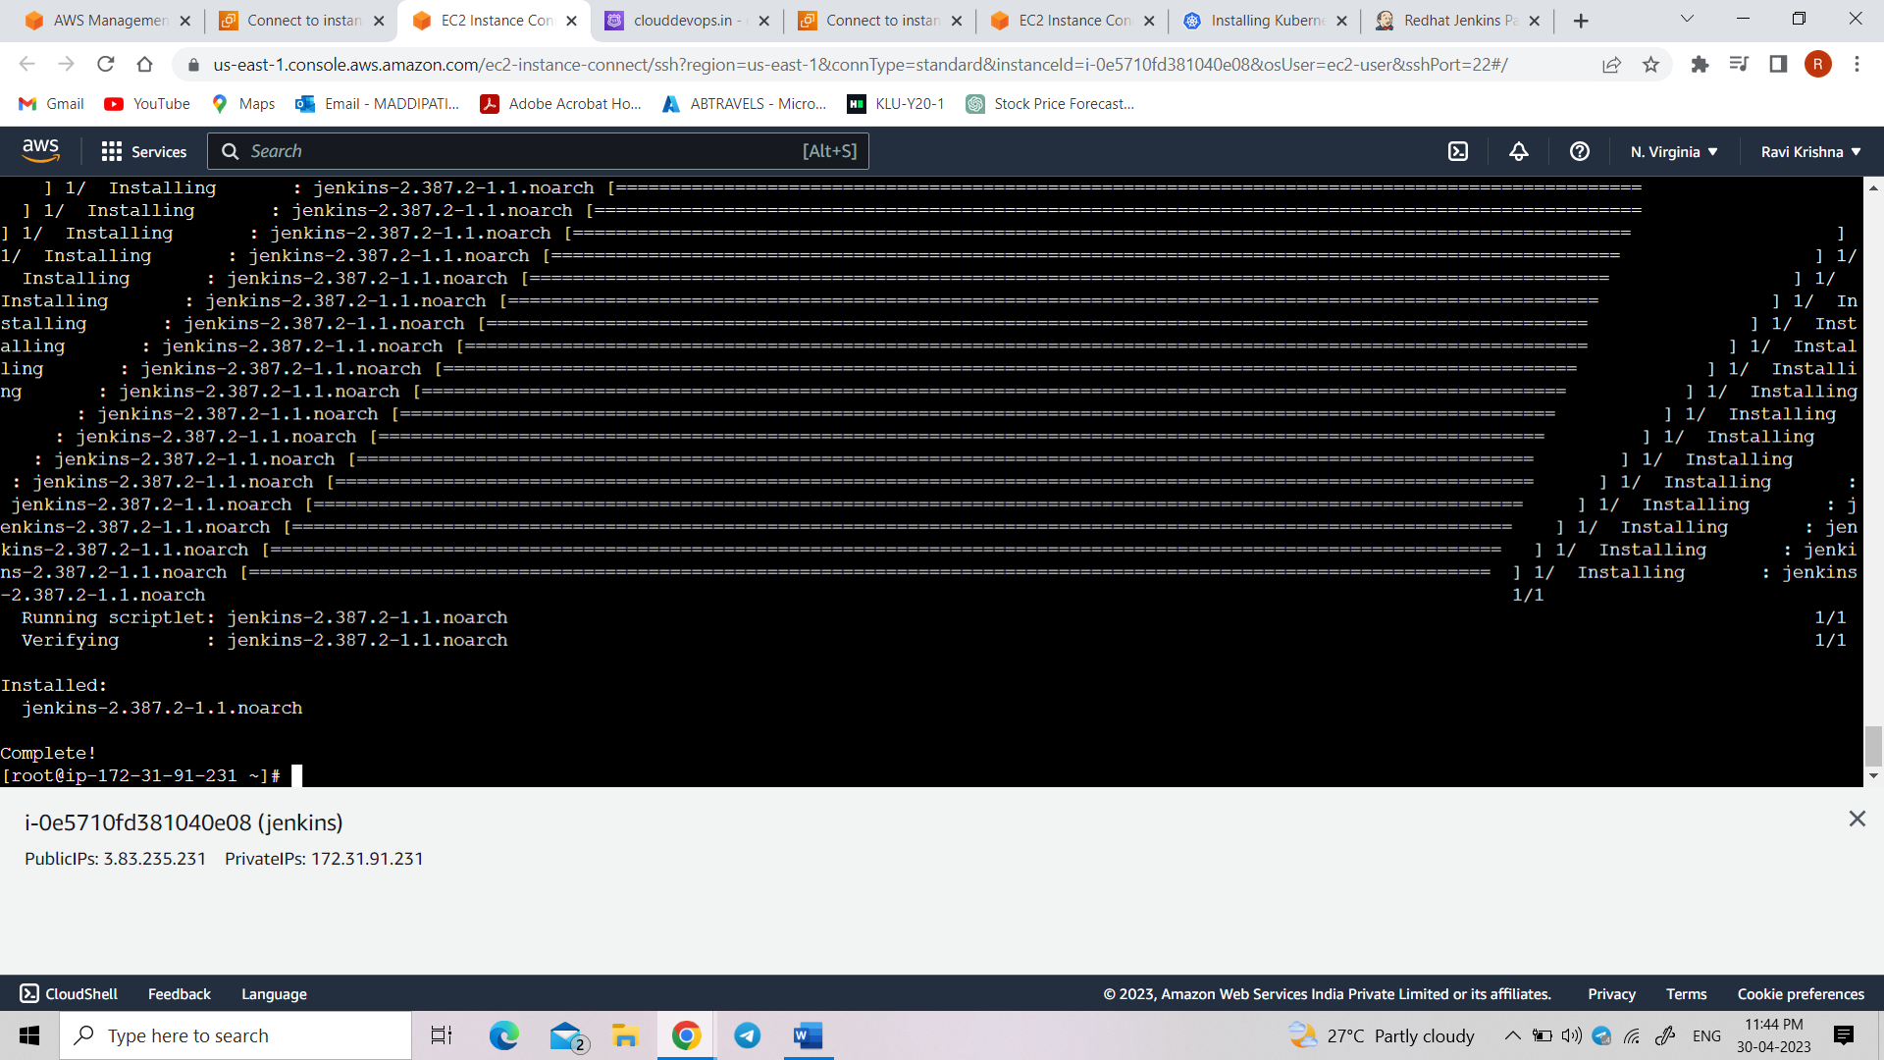

Now type systemctl start jenkins, systemctl enable jenkins

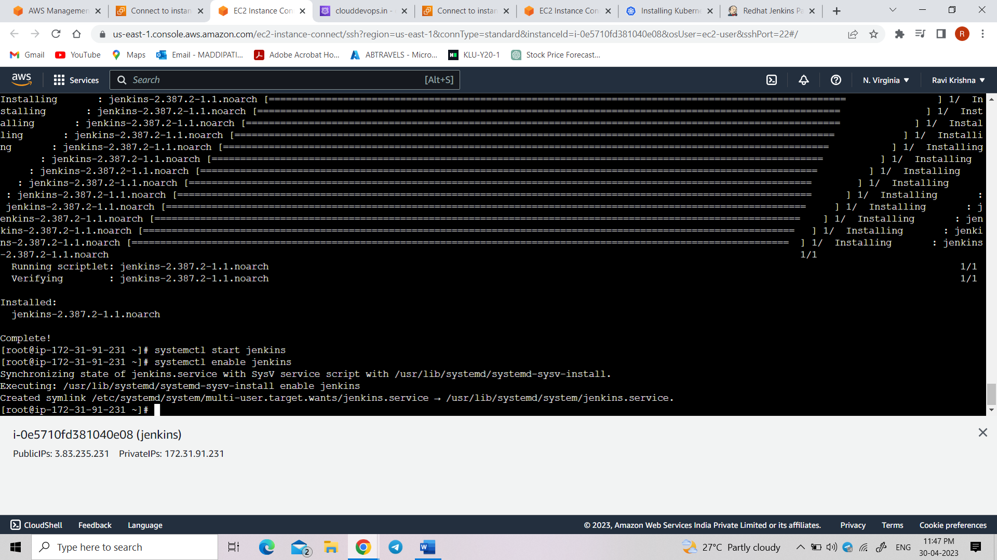

Open Jenkins

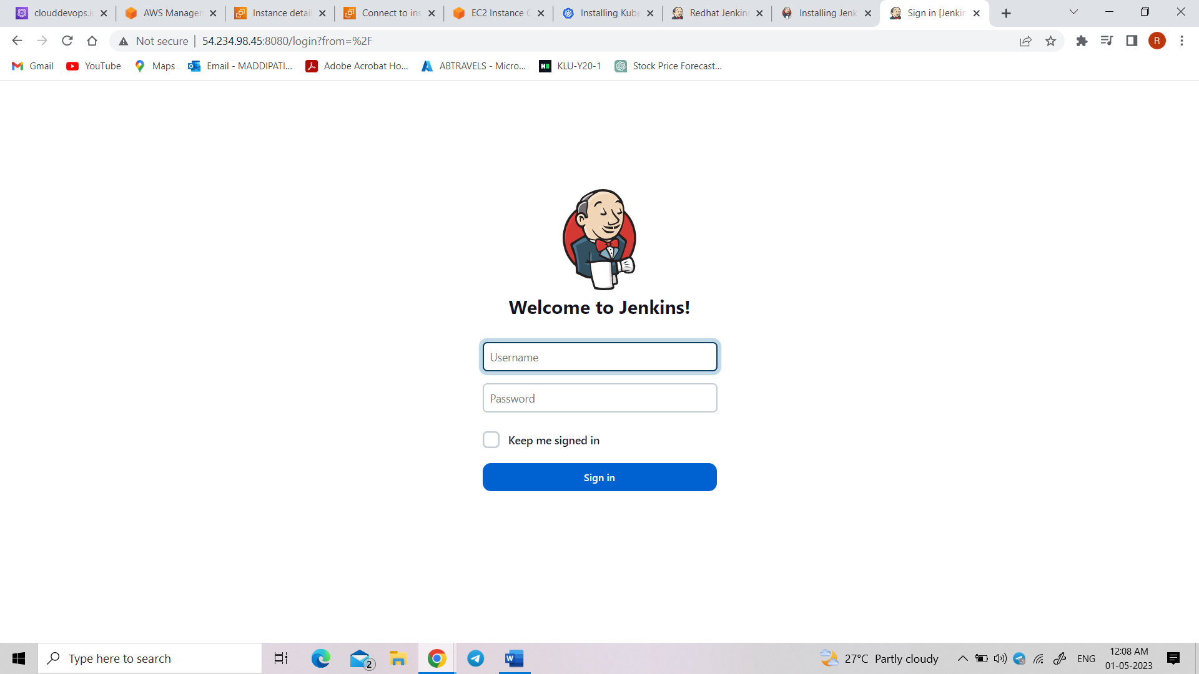

In manage Jenkins go to available and type ssh and select it

